https://github.com/sammy856/Axion-Project-on-AKS-with-Terraform-ADO-domain-and-subdoamin-AGIC.git

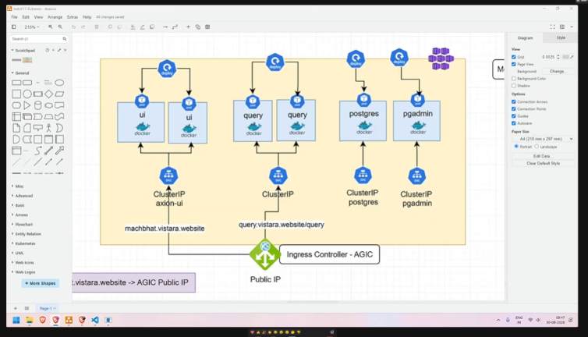

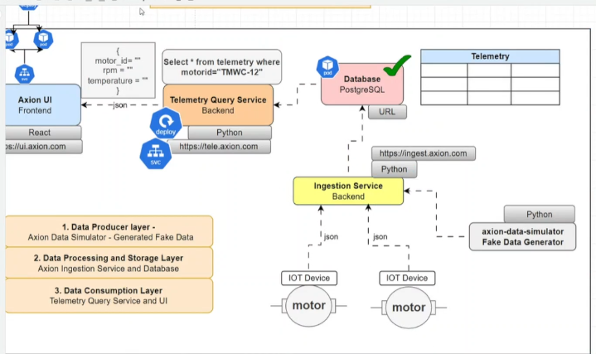

Storage account-
Container
Sp
Sp -role assignment s
Storage role assigments

Roles khud ko secrets banane ke liye
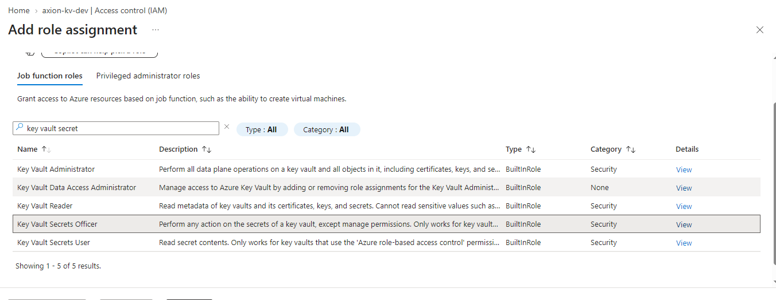

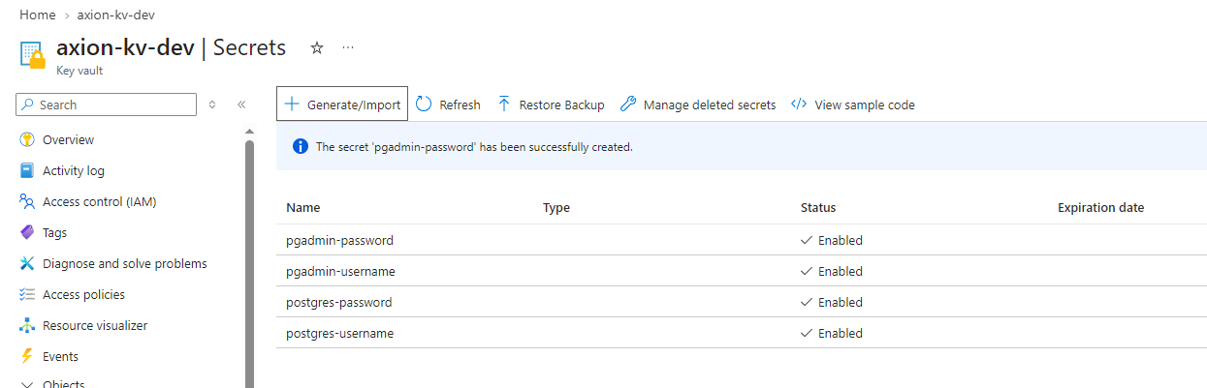

Aks managed identity banao
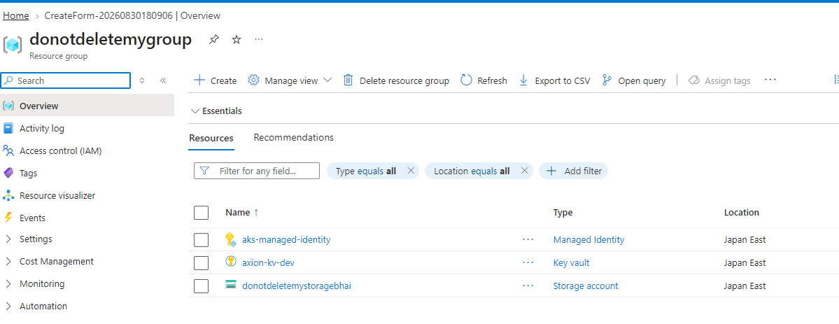

Keyvault pe role denege aks managed identity, basically ye user assigned managed identity hai
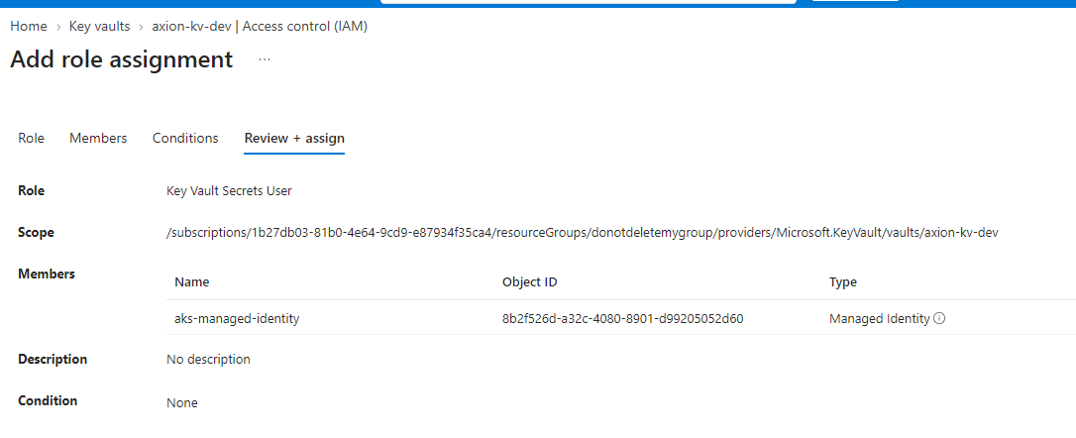

OIDC, CSI driver, Worload identity ko enable karna hai
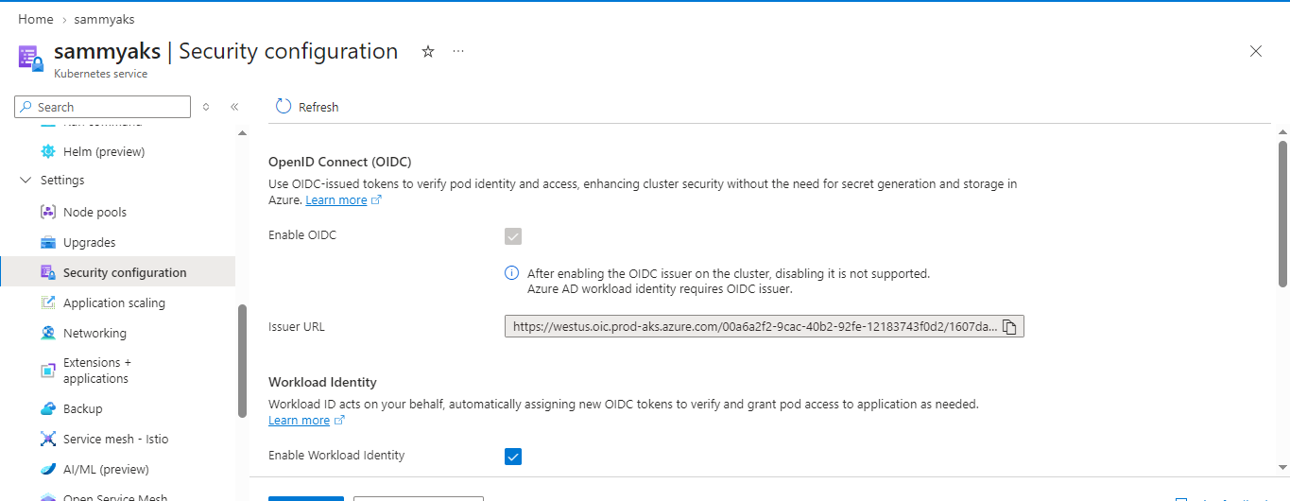

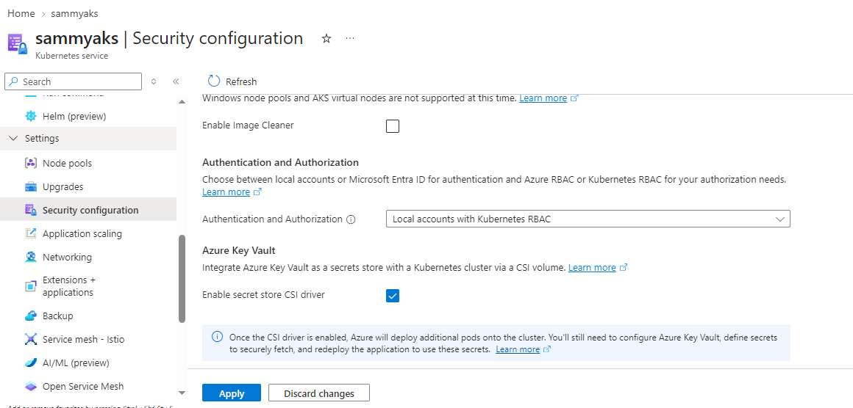

Managed identity me federated credentials add karenge
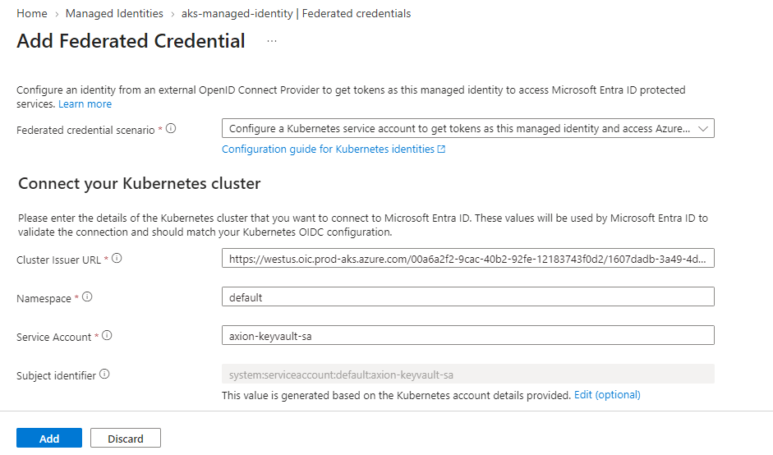

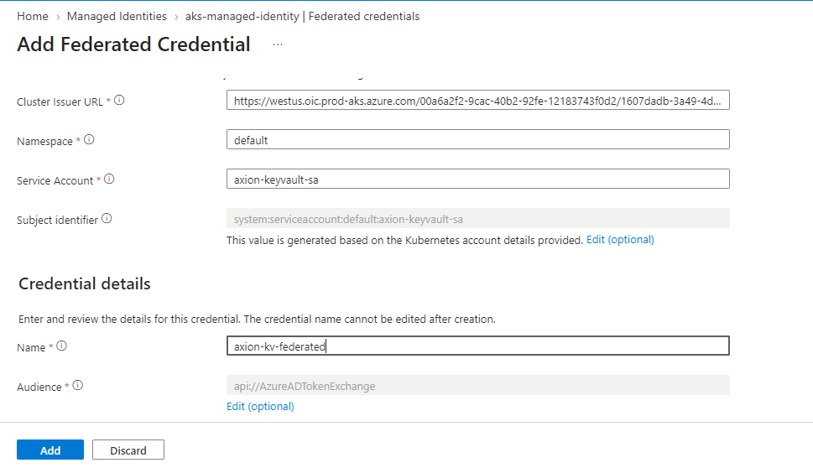

1 service account banayege
Uami ki clinet id dalenge- annotation me
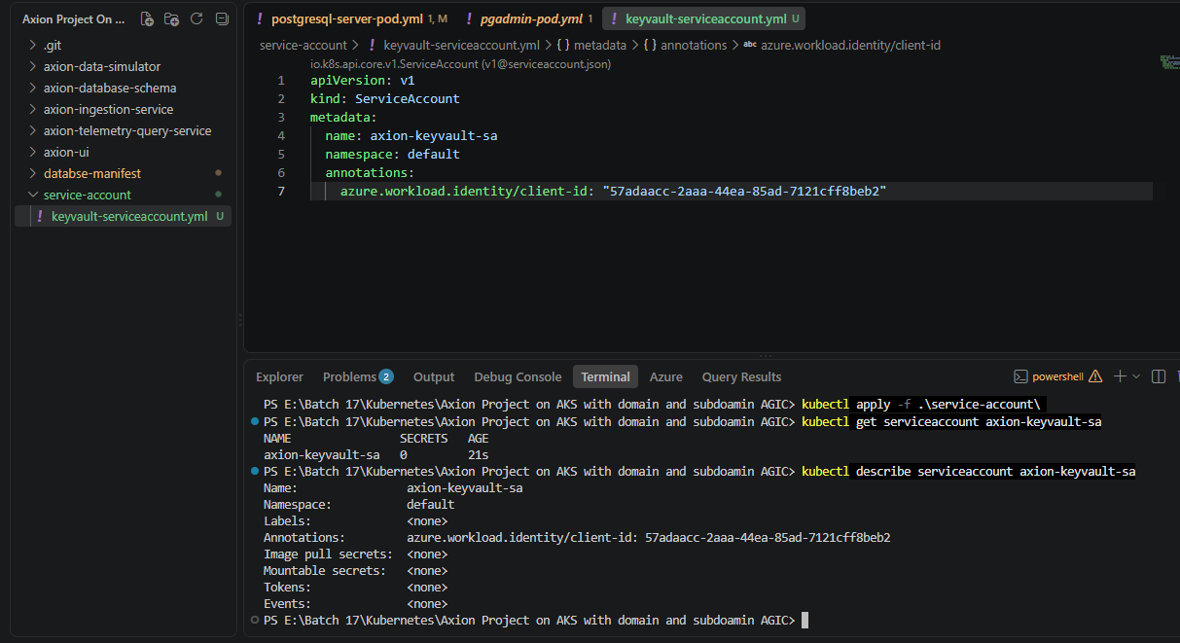

Perfect bhai 👍 Ab Step 8 — SecretProviderClass banayenge. Ye object AKS ko batayega ki Key Vault se kaunse secrets uthane hain.
Is step me hum Kubernetes Secret bhi create karwa denge, taaki PostgreSQL aur pgAdmin ke existing Pods apne POSTGRES_PASSWORD / PGADMIN_PASSWORD jaise environment variables me use kar saken.
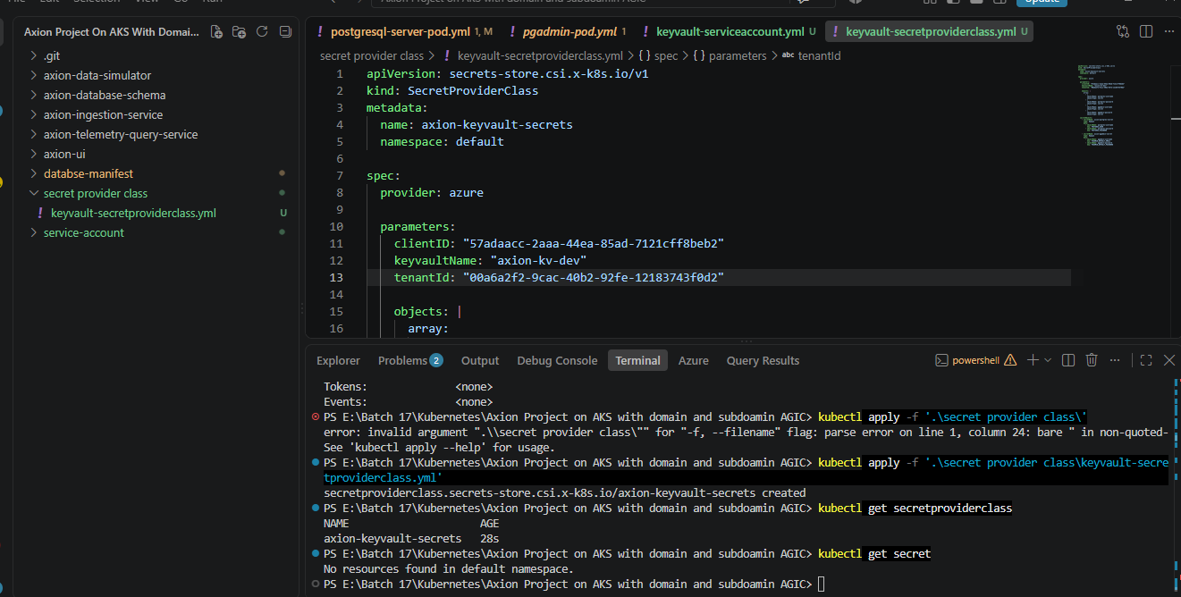

apiVersion: secrets-store.csi.x-k8s.io/v1
kind: SecretProviderClass
metadata:
name: axion-keyvault-secrets
namespace: default
spec:
provider: azure
parameters:
clientID: "57adaacc-2aaa-44ea-85ad-7121cff8beb2"
keyvaultName: "axion-kv-dev"
tenantId: "00a6a2f2-9cac-40b2-92fe-12183743f0d2"
objects: |
array:
- |
objectName: postgres-username
objectType: secret
- |
objectName: postgres-password
objectType: secret
- |
objectName: pgadmin-username
objectType: secret
- |
objectName: pgadmin-password
objectType: secret
secretObjects:
- secretName: axion-postgres-secret
type: Opaque
data:
- objectName: postgres-username
key: POSTGRES_USER
- objectName: postgres-password
key: POSTGRES_PASSWORD
- secretName: axion-pgadmin-secret
type: Opaque
data:
- objectName: pgadmin-username
key: PGADMIN_DEFAULT_EMAIL
- objectName: pgadmin-password
key: PGADMIN_DEFAULT_PASSWORD

Pgadmin bbi change karenge

# apiVersion: apps/v1
# kind: Deployment
# metadata:
# name: pgadmin-pod
# spec:
# selector:
# matchLabels:
# app: pgadmin-pod
# template:
# metadata:
# labels:
# app: pgadmin-pod
# spec:
# containers:
# - name: pgadmin-pod
# image: dpage/pgadmin4:latest
# ports:
# - containerPort: 80
# env:
# - name: PGADMIN_DEFAULT_EMAIL
# value: "sameersingh856@gmail.com"
# - name: PGADMIN_DEFAULT_PASSWORD
# value: "Sammy@0786"
#########################
# deployment with secrets from keyvault using secret provider class
apiVersion: apps/v1
kind: Deployment
metadata:
name: pgadmin-pod
spec:
selector:
matchLabels:
app: pgadmin-pod
template:
metadata:
labels:
app: pgadmin-pod
azure.workload.identity/use: "true"
spec:
serviceAccountName: axion-keyvault-sa
containers:
- name: pgadmin-pod
image: dpage/pgadmin4:latest
ports:
- containerPort: 80
env:
- name: PGADMIN_DEFAULT_EMAIL
valueFrom:
secretKeyRef:
name: axion-pgadmin-secret
key: PGADMIN_DEFAULT_EMAIL
- name: PGADMIN_DEFAULT_PASSWORD
valueFrom:
secretKeyRef:
name: axion-pgadmin-secret
key: PGADMIN_DEFAULT_PASSWORD
volumeMounts:
- name: secrets-store
mountPath: "/mnt/secrets-store"
readOnly: true
volumes:
- name: secrets-store
csi:
driver: secrets-store.csi.k8s.io
readOnly: true
volumeAttributes:
secretProviderClass: axion-keyvault-secrets

Dababse me query add karenge

Databse right click>query tool

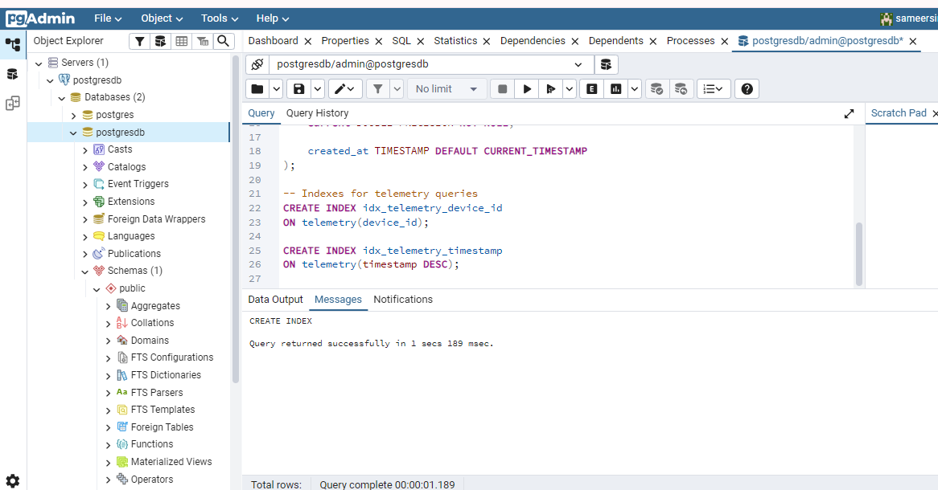

Error
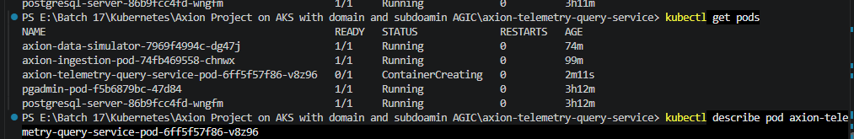

Kubectl describe pod podname
DownwardAPI: true
QoS Class: BestEffort
Node-Selectors: <none>
Tolerations: node.kubernetes.io/not-ready:NoExecute op=Exists for 300s
node.kubernetes.io/unreachable:NoExecute op=Exists for 300s
Events:
Type Reason Age From Message
---- ------ ---- ---- -------
Normal Scheduled 3m20s default-scheduler Successfully assigned default/axion-telemetry-query-service-pod-6ff5f57f86-v8z96 to aks-system-16203905-vmss000000
Warning FailedMount 73s (x9 over 3m21s) kubelet MountVolume.SetUp failed for volume "secrets-store" : rpc error: code = Unknown desc = failed to get secretproviderclass default/azure-keyvault-secrets, error: SecretProviderClass.secrets-store.csi.x-k8s.io "azure-keyvault-secrets" not found
yaha deployment me SecretProviderClass ka name galat tha jo ki axion-keyvault-secrets hona chahiye

Dobara pply karne pe bhi issue aaya
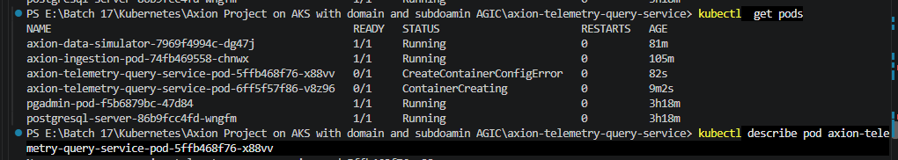
Describe karne pe error mila
152ms including waiting). Image size: 62351194 bytes.
Normal Pulled 105s kubelet Successfully pulled image "sammyacr.azurecr.io/telemetry-query:v1" in 147ms (147ms including waiting). Image size: 62351194 bytes.
Normal Pulled 94s kubelet Successfully pulled image "sammyacr.azurecr.io/telemetry-query:v1" in 259ms (259ms including waiting). Image size: 62351194 bytes.
Normal Pulled 82s kubelet Successfully pulled image "sammyacr.azurecr.io/telemetry-query:v1" in 151ms (151ms including waiting). Image size: 62351194 bytes.
Normal Pulled 68s kubelet Successfully pulled image "sammyacr.azurecr.io/telemetry-query:v1" in 170ms (170ms including waiting). Image size: 62351194 bytes.
Normal Pulled 28s (x3 over 55s) kubelet (combined from similar events): Successfully pulled image "sammyacr.azurecr.io/telemetry-query:v1" in 210ms (210ms including waiting). Image size: 62351194 bytes.
Normal Pulling 13s (x13 over 2m41s) kubelet Pulling image "sammyacr.azurecr.io/telemetry-query:v1"
Warning Failed 0s (x14 over 2m39s) kubelet Error: secret "postgres-secret" not found
PS E:\Batch 17\Kubernetes\Axion Project on AKS with domain and subdoamin AGIC\axion-telemetry-query-service>

---------------------
Telemetry ka subdomain banaya chalaya to bad gateway aaya

App gateway me backedn add ni hua,listenere bhi add nihua

Isseu - ingress me annotation ni lagaya

apiVersion: networking.k8s.io/v1
kind: Ingress
metadata:
name: axion-telemetry-ingress
namespace: default
annotations:
kubernetes.io/ingress.class: azure/application-gateway
spec:
ingressClassName: azure-application-gateway
rules:
- host: telemetry.b18g151.online
http:
paths:
- path: /
pathType: Prefix
backend:
service:
name: axion-telemetry-query-service
port:
number: 80

Telemetry ke main.py me changes

"""
Axion Telemetry Query Service
"""
import logging
from fastapi import FastAPI, HTTPException
from config import settings
from database import pool, connect_to_database, close_database

logging.basicConfig(
level=logging.INFO,
format="%(asctime)s | %(levelname)-8s | %(message)s",
)
logger = logging.getLogger(__name__)

app = FastAPI(
title="Axion Telemetry Query Service",
version="1.0.0",
)

@app.on_event("startup")
async def startup():
await connect_to_database()

@app.on_event("shutdown")
async def shutdown():
await close_database()

# --------------------------------------------------
# Root endpoint
# --------------------------------------------------
@app.get("/")
async def root():
return {
"service": "Axion Telemetry Query Service",
"status": "running"
}

# --------------------------------------------------
# Health check endpoint
# --------------------------------------------------
@app.get("/health")
async def health():
return {
"status": "healthy"
}

# --------------------------------------------------
# Get telemetry data
# --------------------------------------------------
@app.get("/api/v1/telemetry")
async def get_telemetry():
if pool is None:
raise HTTPException(
status_code=503,
detail="Database connection is not available",
)
query = """
SELECT *
FROM public.telemetry
ORDER BY id DESC
LIMIT 100;
"""
async with pool.acquire() as connection:
rows = await connection.fetch(query)
return {
"count": len(rows),
"data": [dict(row) for row in rows],
}

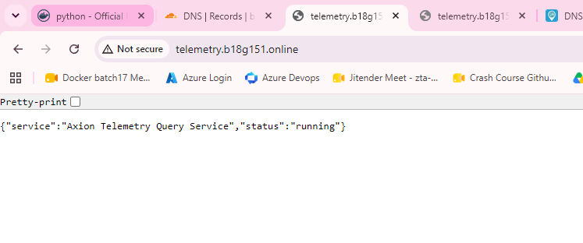

Ab ui bananahai

bhai mujhe ye project deploy karna hai, isme thodi si dikkat hai, jab mai ui bana raha hu to usme data show ni kar raha , devices , dashboard
me , telemetry chal jataa hai, databse me bhi data aa raha hai, tum jayad kuchh change mat karna, jaise maine simulator me ingestion ki service
de rakhi hai usko change mat karna , bas ui me data aana chahiye

Start again

  - AKS Managed Identity — jo already bani hui hai
  - Key Vault — jo kal ka hi hai
  - AKS me Workload Identity enable
  - OIDC issuer enable
  - Key Vault Secrets Store CSI Driver / Azure provider
  - RBAC assignments
    - Managed Identity → Key Vault par Key Vault Secrets User
    - Agar identity ko certificates/keys bhi chahiye to corresponding roles
  - Federated Identity Credential -dobara banega
  - Kubernetes ServiceAccount ko identity se bind
  - Pod me Key Vault secrets mount/test

1.service account
2.scret provider class
3.DB, pgadmin
4.ingestion
5.simulator
6.telemetry-query, manifest, ingress- app gateway enable , agic enable , domain add for app gateway ip
7.ui, manifest ingress, domain add for app gateway ip

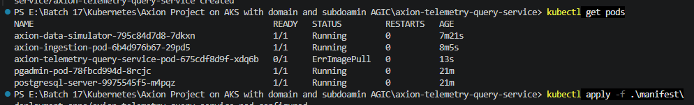
Deployment me image url, imaga name galat
Acr me image hai hi ni
Image push ni hui acr me
Aks ko acr pull access ni hai
Uami ko access ni hai

